Lumi Nova: Digital Support for childhood anxiety
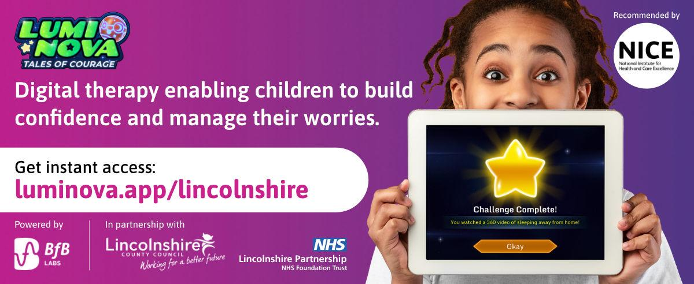

Lumi Nova is available to families in Lincolnshire in collaboration with Lincolnshire County council, NHS Lincolnshire Integrated Care Board and Lincolnshire Partnership NHS Foundation Trust. Lumi Nova is being piloted to support children and young people aged 7-12years to build confidence and learn lifelong skills to manage their worries through an intergalactic adventure game!

No referral required - the offer is instantly accessible to Lincolnshire families by visiting luminova.app/lincolnshire.

We would like to invite professionals working with young people and families in Lincolnshire to join a live Lumi Nova Discovery (45 minute webinar) to learn more about Lumi Nova. Multiple dates are available:

Lumi Nova Discovery Registration

Powered by science, backed by the NHS: Lumi Nova combines Cognitive Behavioural Therapy (CBT) with responsible, age appropriate mobile gaming to provide early intervention, therapeutic support for childhood anxiety. Lumi Nova is:

- Designed for children aged 7-12 years
- Suitable for mild to moderate anxiety
- Provides Exposure Therapy & Psychoeducation (CBT)
- Safe & Secure
- Recommended by the National Institute of Health and Care Excellence (NICE)

Watch this short animated video to learn more:Lumi Nova Introduction Video

Stay connected: Subscribe to the Lumi Nova Newsletter and follow us on social media to stay up to date with new resources and updates that you can share with your community.
Lumi Nova Newsletter
Facebook
Twitter

Spread the word: Check out the Lumi Nova Resource Kit for assets to support you to share information about Lumi Nova with families.

If you have any further questions, please don’t hesitate to reach out to the Lumi Nova team at luminova@bfb-labs.com

