Minutes for FGB Meeting at Lincoln/Zoom:
at 4:30pm on 22.06.2023
Meeting Focus: Budget; Hope Network Update; Staffing Structure; Communication with Stakeholders; Link Governor Reports

Agenda No | Minutes | Action required
1. | Decl of Interest/ Apologies/Attendance:  No new D of I.  Apologies accepted for: A.M , G.B. SB  Attendance:  Zoom/Teams - IH, SM, JS  Lincoln – B.L, C.N, P.B, BT, MW.
2. | Minutes from previous meeting:  Non-confidential minutes have been proposed by S.M and seconded by M.W, all agreed.  Confidential minutes have been proposed by M.W and seconded by S.M, all agreed. | Clerk
3. | Matters Arising:  The energy efficient grant has now been used up; this will be discussed further at the strategy meeting. B.T has written to DL regarding successes. It was discussed that other stakeholders should receive the newsletter, which B.L agreed with. The summary of the SEF should also be put on the school website. | BL  BL
4. | Policies to be agreed:  Mental health and wellbeing policy was proposed by P.B and seconded by M.W, all agreed.  Positive Behaviour policy was proposed by I.H and seconded by P.B, all agreed.  It was agreed at the strategy meeting, to look at how we are going to monitor policies better going forward. | Clerk
5. | Chair’s action:  Strategy meeting was discussed and SLT are to meet with Governors as well, and combine the two meetings together.  The statement of behaviour has now been accepted.  B.T was involved in the interview which lead to B.L becoming the temporary Executive Assistant Head Teacher, starting 1st June 2023 until September 2024. In this role, B.L and the chair will meet regularly to discuss Pilgrim School issues and S.B will join these meetings as and when available. The FGB welcomed B.L to the meeting and confirmed her associate membership of the group during this appointment.
6. | Meeting focus:  Nothing to report.
7. | Head Teacher’s Report:  This has now been renamed from Head Teacher’s report to SLT report. We went through the headings with B.L talking through it. Discussion around the work experience and how this is very successful. Exams have gone very smoothly this year. Discussion around challenges and B.L explained all of these, which Governors are aware of, so they are being kept in the loop successfully. M.W would still like to see the resources report despite the finance report being in the SLT report. KPI is to be added to the School development plan. The school development plan is all very positive.
8. | E-Safety updates and concerns:  Information has been sent out since the last update. Planning to have online safety meeting within the pupil forum meetings. Plan going forward is to keep an annual log of checking systems for safety and where we should be with it; this ties in well with safeguarding. There is now have an online safety course for students to complete.
9. | Curriculum updates and concerns:  This is to be discussed in more detail at the strategy meeting.
10. | Safeguarding updates and concerns:  No concerns regarding this. S.M to meet with B.L or M.F. LA safeguarding assurance is due to be done before the end of term, B.L to do this with either B.T or S.M, S.M is going to try and get into school to get this completed.
11. | Premises incl. Health and Safety updates:  Nothing to report regarding this. M.W to assess how to proceed. | M.W
12. | Base link governors feedback:  Due to it being exam season, no formal base visits have taken place. B.T is to meet with the home team in July. Discuss and review this further at the strategy meeting. | B.T
13. | Finance updates and concerns:  Nothing to report regarding this.
14. | SEND updates and concerns:  Nothing to report.
15. | Wellbeing updates and concerns:  Nothing to report.
16. | Staff updates and concerns:  Nothing to report.
17. | Resources updates and concerns:  Nothing to report.
18. | Hope updates and concerns:  Nothing to report.
19. | As a result of this meeting – Any ‘focus’ changes for next base visits:  Nothing to report.
20. | Ofsted – any training required:  Nothing to report.
21. | Any other business:  Nothing to report.
22. | Date of next meeting:  Strategy meeting has been agreed to take place in the Baumber base on 6th July at 2:30pm. M.W and GB have given apologies for this meeting.

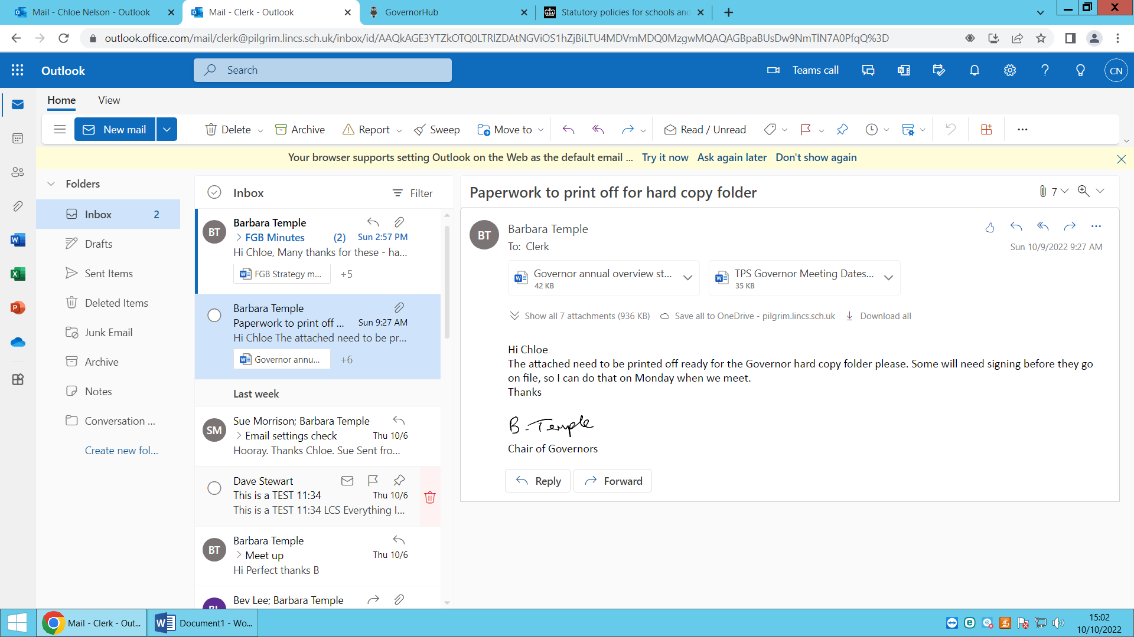

Signed:…… ………………………….

25.09.2023
Date:…………………………………..

