Minutes for FGB Meeting at Lincoln/Zoom:
at 4pm on 26.1.23
Meeting Focus: Budget; Energy Efficiency; Well-Being of Staff and students;

Agenda No | Agenda Item | Minutes | Action Required
1. | Apologies/Decl of Interest | - Apologies from I.H, T.M and P.B. No declaration of interest.  - In attendance for first part of meeting only – BL and HG
2. | Report from BL re Transitions to Post 16 | - The destination report was discussed and talked through. The majority of post 16 students have got secure placements however it has been difficult. EHCP’s often don’t help as destinations will claim they cannot meet need. We only had 2 students who deferred their placements until January, who have now started.  - Transition for our post 16 students is being done correctly and PSWS’s work closely with the students to make this a success. There was some discussion around the PSWS’s sometimes still support the students once they have moved onto their destination, this has raised concerns due to funding and insurance as technically, that student is no longer on our roll, this is to be looked at, H.G to check if our public liability insurance covers us with this, if not we need to look at getting some insurance as it is beneficial for the students to carry on having that support after the summer holidays. I.H to discuss this with B.L. | I.H
3. | Meeting focus - Report from HG re Premises/Building plans/ Health and Safety | - We are still unsure on what the bill will be for our 1-1 tuition, we are delivering more tuition in the home as well as using pastoral staff more, we have a higher carry forward than last time.  - H.G has been planning for our 5 year plan, a 3% increase means better funding.  - Discussion around the Resources Report which is available on the Gov Hub.  - S.B has written to the L.A regarding when we are going to receive the funding. Chair to remind the L.A that S.B has written to them and is awaiting a reply.  - We have a positive carry forward.  - The LED lighting has now been installed in Lincoln.  - We are currently recruiting ES Teachers and new staff across the bases.  - Discussion around when we are going to get confirmation of the 5 year plan with 3%. H.G has got a meeting with the L.A Friday 3rd February, she is happy to take any questions from Governors to this meeting.  - Discussion regarding the asset plan, the energy grant needs to be used before March 2025. Lincoln have had LED lighting fitted, Amber Hill is needing one of the fire doors replacing which will be a cost of around £4000 and Baumber needs the fencing doing which will cost around £6000, all Governors are happy for this to go ahead.  - H.G and S.B have been through the sustainability report, access to this via the Gov Hub. H.G read through this explaining it and there were discussion around this. H.G has a meeting on Friday 27th January about solar panels and will report back.  - Health and Safety report has been completed. | Chair
AFTER THEIR REPORTS, BL AND HG LEFT THE MEETING WHICH THEN FOLLOWED THE SET AGENDA
4. | Minutes of Meeting 17.11.22 | - Minutes from previous meeting were agreed by all, proposed by M.W and second by S.M.
5. | Matters arising including strategy planning | - The resources report has received feedback.  - Strap line is to be put on the strategy summaries on the website which S.B agreed to. The Hope Curriculum pictures are not inclusive and it has been agreed to change this.  - The Owl Communication tool is still a working progress.  - Send the safeguarding training link to be sent to relevant Governors to complete training.  - The E-Safety Team in base stills needs to be set up and running.  - Part 17 of S.B report had a discussion regarding the Governors part of it and whether their role and responsibilities are accurate.  - Letter to thank the police has been sent. | Head Teacher  Clerk  Clerk  J.S
7. | Policies to agree (copies on the Hub) | - All policies have been uploaded the the Gov Hub to be read by Governors.  - It was agreed that the Behavior Policy is to be extended to Easter and the Attendance Policy to be extended until March. The SEND Policy has also been agreed to be deferred until March.  - ECT Policy was spoken about regarding the roll of the Governing body, there was a discussion around this and all are happy to agree it for now, but Governors need to look closer at section 5. Clerk to remove the yellow highlights.  - All agreed and happy with the premises management policy.  - Health and Safety Policy has also been agreed. The green parts of the Policy is personalized to Pilgrim. | Clerk/Chair
8. | Headteacher’s report | - The report is available to read on the Gov Hub. Instead of it being a Head Teacher’s report this time it has been done as an SLT report.  - S.B talked through the report. Discussion around staff time, concerns and query about supervising the drama therapist, (the school counsellor) and it was explained that any volunteers are under our public liability insurance and is monitored by the base lead.  - There was a discussion about the website development.  - It was queried if we have kept track of attendance previously, we have, and however, it wouldn’t be accurate due to data changes within the school.  - Governors would like a report on the staff absence management, S.B to do this.  - Governors would like to be invited to the Easter inset day to attend relevant training. | Head Teacher
9. | Base Link Governors Feedback dates for next visits - Lincoln; Amber Hill; Baumber; Home Learners | - Base visits have been planned and we are moving forward with this.  - GB has visited Baumber and will write up his report.
10 | Safeguarding updates and concerns | - Nothing further to report.
11 | Premises incl. Health and Safety updates | - Discussed under item 3
12 | E Safety updates and concerns | - Nothing further to report.
13 | Finances updates and concerns | - Discussed in agenda item 3.
14 | SEND updates and concerns | - Nothing further to report.
15 | Well-Being updates and concerns | - Nothing further to report.
16 | Staffing updates and concerns | - Nothing further to report.
17 | Resources updates and concerns | - Discussed in agenda item 3.
18 | Curriculum updates and concerns | - Discussed in item 3.
18 | Hope Network updates and concerns | - Nothing further to report.
19 | As a result of this meeting - Any ‘focus’ changes for next base visits | - A continuation from items raised under matters arising
20 | Ofsted – any training required | - Nothing further to report.
21 | Any other business | - None.
22 | Date of next meeting – 9.3.2023 | - Meeting ended at 5:47pm – next meeting 9th March 2023. | Clerk

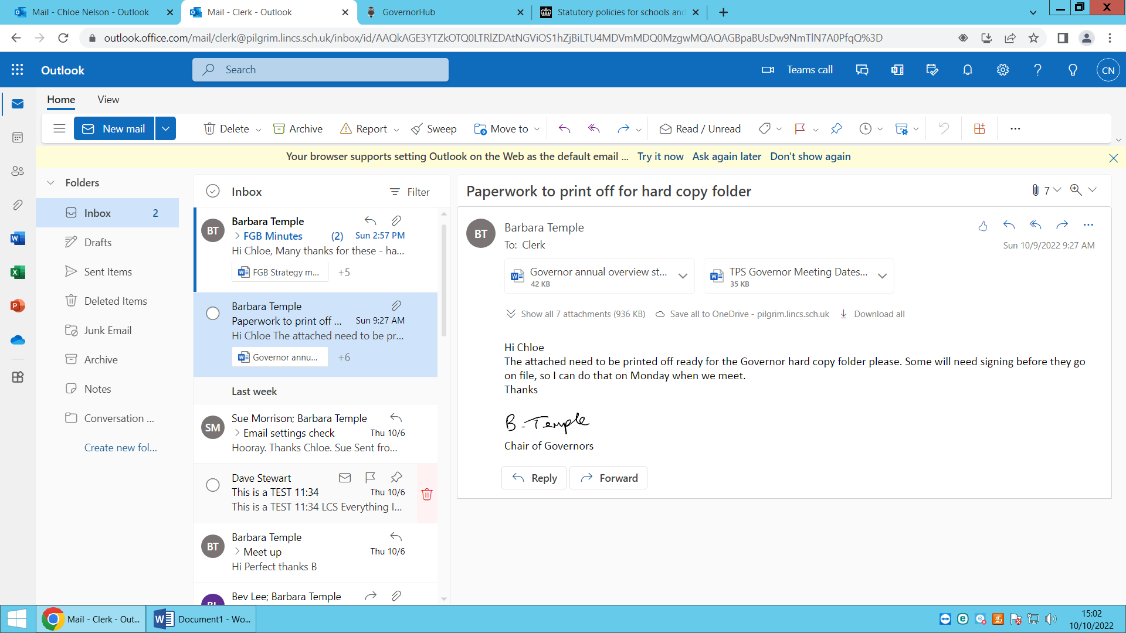

Signed………………………………….

09.03.2023
Date…………………………................

