Minutes for FGB Meeting at Amber Hill/Zoom:
at 4pm on 17.11.22
Meeting Focus: Budget; Hope Network; Appraisals; Home Learners Progress; Equity of Provision; Link Governor Report
Agenda No | Agenda Item | Minutes | Action required
1. | Apologies/Declaration of Interest | - Apologies: G.B, T.M, C.N (Due to technical difficulties clerk was unable to attend so S.S took notes).
2. | Meeting focus – Home Learners Progress Presentation 4.05pm-4.25pm | - Excellent update of the progress being made for all the home based learners. Tracking documents were used to illustrate the safeguarding procedures in place. The sheer volume of work carried out since the last Governors presentation in March this year is very impressive and thanks were given to S.S and her hard working team.
3. | Resources Report – SBM 4.25pm-4.45pm | - H.G provided a report for resources and talked through the report including staffing and utilities.  - Chair discussed looking at a 5 year strategy overall/5 year forecast. Discussion as to whether we look at combining groups to look at all resources for the next 5 years.  - This was unanimously agreed.  - Discussed how there are a lot of unknowns at the moment and what could be done regarding this.  - Expenditure and income based on no increase was questioned.  - Discussion around funding for schools and whether there could be any increases, H.G has met with the LA to discuss this and upcoming meetings are in Christmas holidays and February half term.  - Discussion around pupil numbers and referrals increasing.  - H.G highlighted that claim back from LA home tuition has increased and the LA are looking into the cost of this.  - We have received quotes from 2 providers for electrical work (LED Lighting in Lincoln), these are from the LA and a private contractor, and private contractor is the cheapest, Governors approved the private contractor who has completed work for the school before.  - Discussion regarding Neil looking into outdoor fitness equipment bids and working with a company to write a bid up to secure funding for this, Governors are in agreement to use school fund to ask the company to write up a bid for the fitness equipment.  - Discussion around the name change for the ‘RSO’ and Governors agree that the new title describes the job better, however to be mindful that ‘reintegrate’ is no longer in the title.  - T.A in Lincoln who is leaving at Christmas is not being replaced straight away, agency T.A has been used for Baumber, a job has been advertised for a T.A and we have received several applicants.  - SFVS document has been looked at and was agreed to have a clear point of references with named Governors.  - Discussion around SDP and whether it should have a financial part to it, S.B agreed that a column should be added for this if needed.  - Queries raised which H.G explained clearly.  - SFVS approved and agreed by all. | Working party to look at 5 year plan for resources.
4. | Minutes of Meeting 3.10.22 | - Item 7 needs a sentence removing and then minutes are agreed to be a true document.  - 2 versions will be needed due to confidential minutes being included. | Clerk
5. | Matters arising | - Self-evaluation document has been updated and shared on Governor Hub.  - Communication tool is still a work in progress.  - Vision and Values document should now be on the website.  - S.B is to add photos to the full version of the Vision and Ethos document and circulate it out to Governors, this is not to be publicized.  - Clerk checking all safeguarding training has been completed. | Clerk  Head  Head  Clerk
6. | Chair’s Action | - Pay Policy, RSE Policy and Emergency Protocol Policies have been unanimously agreed.  - Base links Governors are asked to monitor that staff are aware of Emergency Protocol and that they know where grab bags are and how to use them.  - Letters to MP’s regarding funding for schools have had some replies.
7. | Base Link Governors Feedback Baumber; Lincoln; Amber Hill; Home Learners | - Base link feedback has been received and is very positive and improved continuity. Discussion around some set format but as things crop up around bases, this can be tailored to particular bases, all agreed this would be useful.
8. | Curriculum updates and concerns | - Feedback from P.B who visited Amber Hill base for Science week, it was a very positive experience and students from all bases came along.
9. | Safeguarding updates and concerns and SEN updates and concerns | - It was suggested that base link Governors use the questions raised by the NGA handout, S.M to advise as to which questions to look for answers.  - S.M had a SEND Zoom call with assistant SENDCO and are meeting again in January.  - S.B updated Governors about staffing for SEND with history and current provision. We currently have B.F was previously acting as SENDCO and E.W acting as assistant, B.F has had to step down so is now mentoring E.W, as temporary SENDCO, interview for this post to take place on 02/12/2022. | SM
10. | Premises incl. Health and Safety updates | - Every base now has a compliance folder which includes, Fire Risk Assessments, Legionella Risk Assessments, Asbestos Register, Weekly Safety Checks, Flushing Records and monthly/yearly compliance checks.  - The signage for First Aid and CCTV across all bases has been increased.  - The school recently ran a very successful First Aid Course for 11 members of staff.  - The LED lighting in Lincoln is due to be replaced in the Christmas Holidays following Governors approval of the contract.  - The Fascia boards at Baumber have been inspected and some repairs have been completed prior to a complete replacement, if required.  - No other concerns or issues.
11. | E Safety updates and concerns | - Update from J.S who is meeting B.L and H.G next week to develop a team. | JS
12. | Finances updates and concerns – including Pay Committee feedback | - The pay committee met up prior to this meeting and everything got approved including staffing and pay, H.G to be informed. | MW
13. | Well-Being updates and concerns | - Updates regarding this was covered in the base reports.
14. | Staffing updates and concerns | - Updates regarding this was covered in the base reports.
15. | Resources updates and concerns – possibly covered in Item 3 | - Updates regarding this was covered in the base reports.
16. | Hope Network updates and concerns | - Update given from I.H who has been linked into the Hope Network staff group from B.L.  - Hope Network inaugural meeting is to go ahead, date is yet to be confirmed.
17. | Head Teacher’s report – Budget and Equity of Provision | - H.T report is available on Governor Hub, S.B gave a review of this.  - Successes of the school was shared.  - Review feedback from the recent mock inspection by lead Ofsted inspector is extremely positive especially safeguarding and attendance. The other 2 Head Teachers involved were impressed with the curriculum and the work of school students.  - S.B has requested a letter be sent to the police for excellent support in recent safeguarding matter.  - B.T asked questions regarding BedRock learning which S.B shared information.  - Equity of provision report was shared and questions were answered and applied according to our setting which S.B talked through.  - Discussion around the composition of the ‘Bridge Group’.  - Discussion around post 16 destinations and whether students are still attending, S.M requested a report of this for the next FGB. | Head/Clerk  Head/Clerk
18. | As a result of this meeting - Any ‘focus’ changes for next base visits | - Emergency Protocol grab bag monitoring.  - Safeguarding checks.
19. | Ofsted – any training required | - This was not discussed.
20. | Any other business | - Nothing to report.
21. | Date of next meeting – 26 January 2023 | - 26th January 2023.

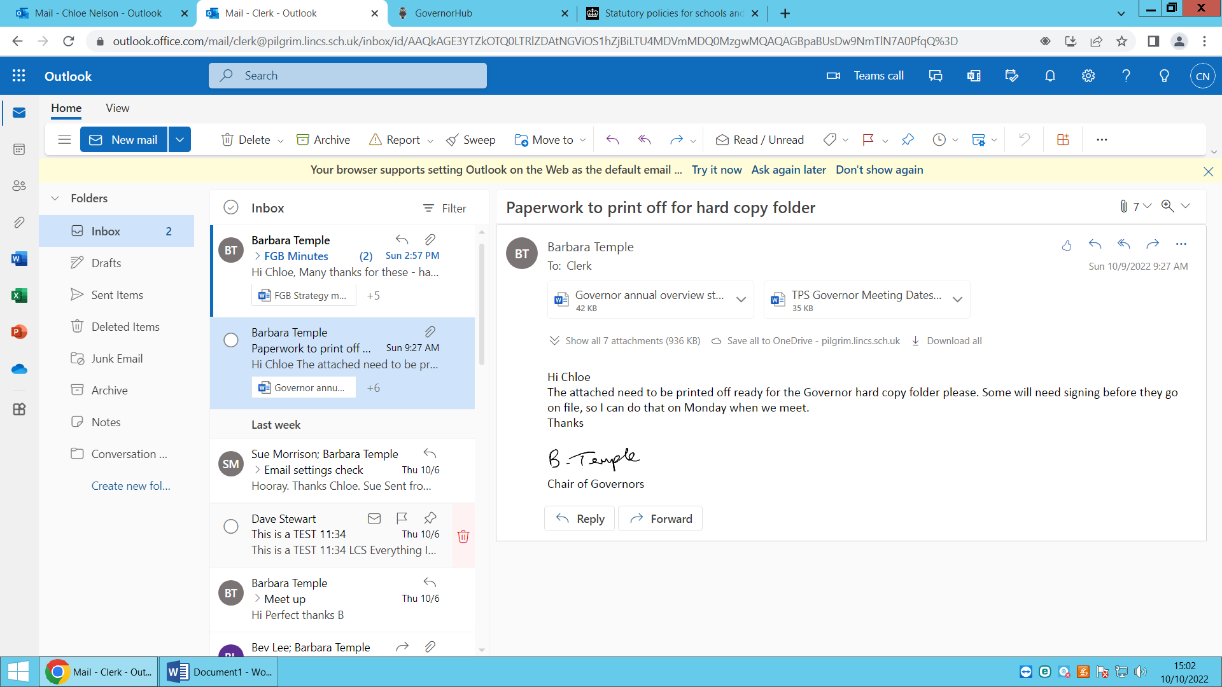
Signed by Chair:

Date: 26.01.2023

