
Guidance to assist with Safeguarding, Attendance and QA arrangements for mainstream schools (last updated /09/2025).
Introduction
Rationale – this guidance has been compiled to support mainstream schools who have a student who is dual registered at The Pilgrim School.
This information is shared with mainstream schools on referral (replacing the letter of comfort) and can be viewed on The Pilgrim School’s website.
The guidance may be used by mainstream schools to complete their safeguarding, attendance, and quality assurance schedules, enabling more time for receiving updates for their dual registered student(s), and more time to meet with them during a visit to our school.
This document is not an exhaustive list. Should you require more detail or to discuss aspects in depth/other matters please speak to a member of SLT during your visit.
Most recent OFSTED report (July 2024): https://www.pilgrim.lincs.sch.uk/ofsted
To arrange a visit to any base please contact:
leadershipteam@pilgrim.lincs.sch.uk
Or telephone Rebecca Ollerton: Lincoln 01522 682319
Useful contacts:
Bev Lee: Executive Assistant Headteacher/ Deputy DSL bev.lee@pilgrim.lincs.sch.uk
Mel Findon: DSL mel.findon@pilgrim.lincs.sch.uk
Elena Wilson: SENDCo/DDSL elena.wilson@pilgrim.lincs.sch.uk

Question | Response
Finding our bases | Baumber base: It looks like you are going up a private drive, but the entrance arrowed below leads to the car park behind the school.  The address is Pilgrim School, Baumber Base, Baumber, Lincoln Road, Horncastle,  LN9 5DN.  On what3words you can find us at: chilled/verifying/appealed  Telephone: 01507 355916  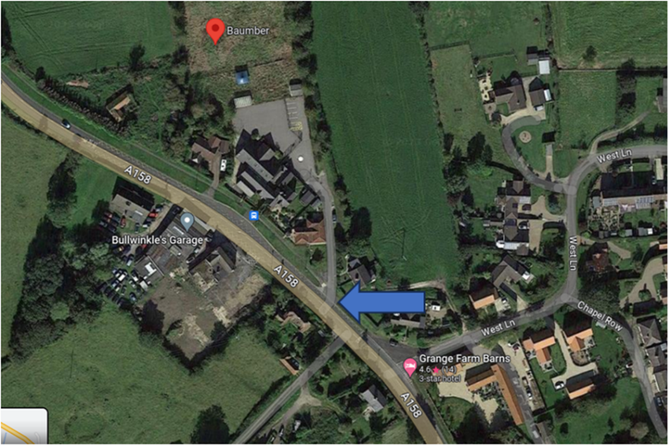  Amber Hill: What 3 words are: challenge/breed/behind  Postcode:PE20 3RQ  Telephone : 01205 743107  Lincoln: What 3 words are: salsa/sheep/keeps  Postcode LN6 0DE  Telephone: 01522 682319
Responsibility for commissioning a placement at Pilgrim | Responsibility for the Alternative Provision used rests with the mainstream school commissioning the placement.
Responsibilities the commissioner (mainstream) holds while a student is at Pilgrim | Once a placement has been agreed, the school maintains responsibility for:  Pupil welfare; safeguarding; child protection; and ensuring parents and pupil are aware of the arrangements.
Quality assurance | The responsibility for quality assurance and evaluation sits with the commissioning school.
Communication
Communication with mainstream | At referral point we ask for a key school contact to be identified. This should be someone that the pupil has a positive and trustful relationship with. It does not need to be a School Leader but there should be regular internal dialogue with the leadership team.  On referral a form is sent out to collect any academic information e.g., curriculum point/exams boards/levels students are working at.  Good practice would be for regular communication between the mainstream ‘key adult’ and Pilgrim team (with the pupil where possible) so that the pupil continues to feel well supported by their mainstream setting. At the very least, this staff member should be the one to attend any review meetings to discuss progress and next steps.  At The Pilgrim School, all pupils are assigned a Pastoral Support & Welfare Specialist (PSWS) and Academic Link (AL) who will have oversight of that pupil’s progress in their respective field. The mainstream ‘key adult’ will be the point of contact for these staff regarding academic and pastoral matters.  Where schools are in receipt of top up funding or pupil premium, some of this may be requested to support identified additional resource at placement, such as access to trips or intervention programs.  Should school leaders require a more general overview of all pupils attending our setting, they can request this from our senior team.
Communication with parents and students | We communicate in the usual ways, e.g. Reach more Parents, email, phone, text, face to face.  We send out Newsletters three times a year. These are also available on our website.  We issue formal annual progress reports to parents/carers.  We offer online parents’ evenings with academic links and teaching staff.  We also have:  Information boards.  Pupil forums.  Parent forums.  Base open mornings.
Recording and sharing academic progress | We routinely keep schools informed of pupil progress and engagement through reviews and share assessment information when requested. Schools are also copied into any timetable changes.
Policies

Location of policies | Relevant policies can be found on the school website at https://www.pilgrim.lincs.sch.uk/policies
Safeguarding
Responsibility | Everyone is responsible for safeguarding in schools.  Responsibility for safeguarding dually registered pupils remains the responsibility of both schools.  Safeguarding responsibility for non-contact days lies with the mainstream school.  Mainstreams should make provision for their own safeguarding checks when students are not timetabled to attend a Pilgrim base or receive home tuition/pastoral visits.  “Where a school places a pupil with an alternative provision provider, it continues to be responsible for the safeguarding of that pupil and should therefore be satisfied that the placement meets the pupils needs”. KCSIE 2025  We routinely inform settings of any timetable changes.  We at The Pilgrim School will ensure:  - Appropriate DBS and Safeguarding checks prior to employment and DBS update service is used;  - All staff receive appropriate annual safeguarding training and 6 termly updates from the DSL/Deputy DSL;  - All staff receive yearly updates and ‘sign off’ KCSIE each year;  - All staff follow the Lincolnshire LSCP 6-year pathway undertaking certificated training yearly;  - The Lincolnshire County Council Policy is followed for whistleblowing procedures;  - All staff undertake annual certificated GDPR training;  - All staff undertake annual certificated Online Safety training.
Training
Training records | We hold a central record of all training pathways and training records, including certificates for all staff.
Updating and monitoring the Single central record (SCR) | The SCR is updated by the school business manager and is checked and monitored by our Safeguarding Governor DSL and Deputy DSL.  Mrs Mel Findon, (Pastoral Manager/DSL)  mel.findon@pilgrim.lincs.sch.uk  Mrs Bev Lee (Executive Assistant Headteacher/DDSL)  Bev.Lee@pilgrim.lincs.sch.uk  Barbara Temple (Chair of governors with responsibility for safeguarding)  barbara.temple@pilgrim.lincs.sch.uk
Recording safeguarding concerns and informing our mainstream schools | We log concerns using our MIS and will share significant events with you (for example, referrals to Children's Services).  More general updates are shared at review meetings/via pastoral plans.
OFSTED safeguarding | 2024 Monitoring visit: Good. Safeguarding effective.
Student concerns | If a student has a concern they can speak to any member of staff, but their PSWS will likely be their first port of call.  Student-friendly information posters are present in base and shared with home students.
Timetables and attendance
Recording attendance | Attendance is recorded on our MIS system (Ed:Gen).
Attendance monitoring | We follow up on absence daily when pupils do not attend as expected.
Attendance calculation | We calculate attendance in two ways; Provision Offered (PO) and Full Time Equivalent (FTE).
Mainstream monitoring of attendance | Mainstream schools can, on request, be issued with an account for our MIS. Alternatively, you may call the appropriate base office for attendance for your student(s). This should happen daily to confirm attendance at expected sessions and therefore current ‘visibility’ of your pupils.  Reminder from safeguarding section: The safeguarding responsibility for non-contact days lies with the mainstream school. Mainstreams should make provision for their own safeguarding checks when students are not timetabled to attend Pilgrim or receive home tuition/pastoral visits (see below for KCSIE updates)  KCSIE 2025 updates:  There is an additional paragraph regarding Alternative Provisions placing more emphasis on mainstream schools placing the child within an Alternative Provision setting to continue to have safeguarding responsibility:  ‘Where a school places a pupil with an alternative provision provider, it continues to be responsible for the safeguarding of that pupil and should therefore be satisfied that the placement meets the pupils needs’. KCSIE 2025
Attendance | We use the DfE recommended codes and record twice a day - AM and PM attendance.  Code D: Dual registered at another school – this is used by mainstreams when students are timetabled at Pilgrim.  Code C: To identify when pupils are not expected to attend Pilgrim as per their current timetable.  Code CS: To identify when pupils have been seen for a safe and well but not attended planned provision.
Mainstream codes | Schools are legally responsible for using the correct codes, which is a safeguarding priority. The appropriate DfE registration code must be used.
Reviews
Contacts | Main point of contact for all students is their PSWS or AL.
Leading reviews | Where pupils are subject to a multi-agency team, we would expect mainstream schools to be Lead Professional, unless there is a parental request otherwise.
Review timescale | Reviews for new pupils will be held at 6, 12 and 18-week points from start date. Following this, reviews will take place regularly to ensure multi-agency practices are in place and students are supported during their attendance at Pilgrim. We encourage the key adult in mainstream schools to maintain communication between reviews and visit the pupil in our setting.
Review format | All parties are invited
Working with other agencies | We work regularly with a range of outside agencies and attend relevant multi agency meetings as required eg TAC, CIN, CP, SEND, MDT etc.
Curriculum
Curriculum organisation and offer | On referral, a form is sent to mainstream for data collection. This should be completed as soon as possible and returned to Pilgrim to ensure a smooth transition.
Curriculum plans | Curriculum information can be found on the school website and from the relevant HOD.  There is an expectation to study Maths, English Language and Literature, Science, PSHE, and a range of options designed to mirror the Mainstream curriculum as closely as possible. Options are chosen at transition from Y9 to Y10, for those pupils likely to remain with us for KS4 and shared with mainstream settings for information. Those pupils anticipated to return should be included in the option processes at their mainstream setting.  Unless agreed with mainstream, students will study Maths and Science with Edexcel and English Language and Literature with AQA.  Pupils at KS3 are offered a curriculum broadly in line with the national curriculum and including core, humanities, activity hour, music, technology and languages. Where reintegration is being explored, we may ask mainstream settings to provide work so that pupils are studying the same topics as their peers ready for transition.
Exams | Each base is registered as a separate exam centre.  We will enter any students if they are not home schooled, a new entry after exam deadline, or studying a course we don’t normally offer or with a board we don't usually work with.  Our Exams Officer, Liz Hallissey liz.hallissey@pilgrim.lincs.sch.uk will liaise with your exams officer for any other entries.
Functional Skills/ELC | We offer Functional Skills from Entry Level 1 up to Level 2 for Maths and English. We also offer the Edexcel Entry Level Certificate in Science. This will not affect any student’s GCSE entry but is considered as an additional qualification.
Personalising learning | Each student has a pupil passport collated by their academic link and regularly updated
Extra-curricular opportunities | We offer a wide range of personal development opportunities including but not limited to Language club, Pride/LGBTQ+ club, Drawing Club, Gardening Club, Anime Club. We also offer several trips out, many based around cultural experiences.
PD and PSHE | We offer a wide range of personal development and PSHE opportunities including:  Spirituality Day  Themed form times and guest speakers  PSHE curriculum (following PSHE Association framework and incorporating statutory RSE elements)  Careers  WOW enrichment sessions  Volunteering and Lifeskills  Duke of Edinburgh
SEND | Where a pupil has an EHC Plan, ensure that you liaise with the Local Authority and inform the SEND Team that the pupil is accessing Pilgrim.  If you have any questions regarding SEND, please contact:  Elena Wilson (SENDCO) - elena.wilson@pilgrim.lincs.sch.uk  We monitor students closely and refer any SEND concerns to our SENDCo.
Quality of Teaching and Learning | We have in house procedures to monitor and evaluate Teaching and Learning including Health Checks.
Pupils and Parents view | We complete a parent and student survey at least once per year, plus parents’ evening and open mornings. Parents are also actively encouraged to contact any member of staff if they have a query about any aspect of their child’s education or wellbeing.
Other information
Free school meals | Please inform Pilgrim if a student receives FSM (there is space for this on the information form)
School transport | Pupils travel to school by Local Authority transport unless they live less than 3 miles from the setting.
Transportation of students | We adopt the Local Authority Travel & Expenses policy  All staff who have business insurance are able to transport students.  All relevant health checks are recorded for staff cars eg MOT, insurance etc  The school have a minibus which receives regular checks according to the local authority schedule and the DVLA eg MOTs, servicing etc.
Quality of accommodation | We have 3 sites – Lincoln, Baumber and Amber Hill. These are regularly monitored by our facilities manager and business manager.
Qualification and experience of staff | All teaching staff hold QTS and are subject specialists, many with experience from other schools.
Health and Safety | Staff receive yearly H and S training updates.  HASAWT is displayed in offices, and the school has a H and S policy.  Health and Safety records are kept in each base.  Medications are recorded, stored and locked.  Accident and Incident books records are kept.  Risk assessments are completed for students if required including for off site visits.
Arrangements for administering First Aid | A high number of our staff are First Aid trained annually.
Fire risk assessment and procedures | Staff receive yearly fire training refreshers. Regular fire drills take place.  Students needing assistance for evacuation hold a PEEP.
Social media and e safety | Staff take part in regular training for this including Cyber security training.
Mental health and wellbeing | Pupils have access to our in-house BACP registered counsellor, and we regularly host placements from partner universities for creative therapies such as art and drama. Referrals to counsellor are only accepted if there is no conflict with CAMHS/other therapeutic input.
Complaints procedure | A complaints policy can be found on the school website.  In the first instance, please contact the Headteacher, Steve Barnes steve.barnes@pilgrim.lincs.sch.uk  or  Barbara Temple, Chair of governors  Barbara.temple@pilgrim.lincs.sch.uk

